Source Data Mapping Approach to CDMV5.4

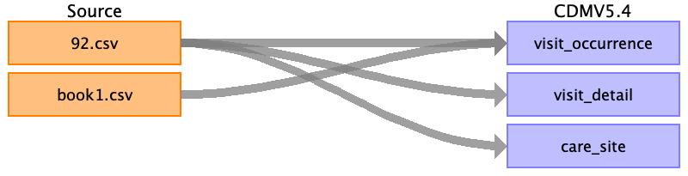

Table name: person

Table name: observation_period

Table name: visit_occurrence

Reading from book1.csv

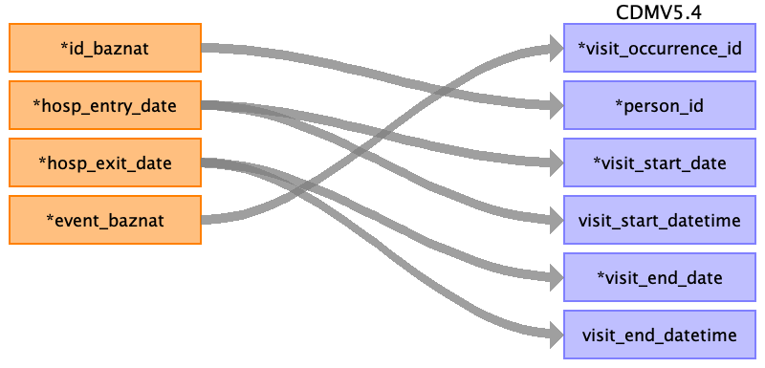

|  |  |  |  |
| --- | --- | --- | --- |
| Destination Field | Source Field | Logic | Comment |
| visit_occurrence_id | event_baznat |  |  |
| person_id | ﻿id_baznat |  |  |
| visit_concept_id |  |  | 9201 |
| visit_start_date | hosp_entry_date |  | Date and time - DD/MM/YYYY HH:MM:SS |
| visit_start_datetime | hosp_entry_date |  | Only date DD/MM/YYYY |
| visit_end_date | hosp_exit_date |  | Date and time - DD/MM/YYYY HH:MM:SS |
| visit_end_datetime | hosp_exit_date |  | Only date DD/MM/YYYY |
| visit_type_concept_id |  |  | EHR_concept_id 32817 |
| provider_id |  |  | Not know! |
| care_site_id |  |  | Based by the care_site table and event baznat. |
| visit_source_value |  |  | Not use in this field. |
| visit_source_concept_id |  |  | Not use in this field. |
| admitted_from_concept_id |  |  | 0 |
| admitted_from_source_value |  |  | Not use in this field. |
| discharged_to_concept_id |  |  | Not use in this field. |
| discharged_to_source_value |  |  | Not use in this field. |
| preceding_visit_occurrence_id |  |  | Not use in this field. |

Reading from 92.csv

Generated

|  |  |  |  |
| --- | --- | --- | --- |
| Destination Field | Source Field | Logic | Comment |
| visit_occurrence_id |  |  |  |
| person_id |  |  |  |
| visit_concept_id |  |  | 9201 |
| visit_start_date |  |  | Date and time - DD/MM/YYYY HH:MM:SS |
| visit_start_datetime |  |  | Only date DD/MM/YYYY |
| visit_end_date |  |  | Date and time - DD/MM/YYYY HH:MM:SS |
| visit_end_datetime |  |  | Only date DD/MM/YYYY |
| visit_type_concept_id |  |  | EHR_concept_id 32817 |
| provider_id |  |  | Not know! |
| care_site_id |  |  | Based by the care_site table and event baznat. |
| visit_source_value |  |  | Not use in this field. |
| visit_source_concept_id |  |  | Not use in this field. |
| admitted_from_concept_id |  |  | 0 |
| admitted_from_source_value |  |  | Not use in this field. |
| discharged_to_concept_id |  |  | Not use in this field. |
| discharged_to_source_value |  |  | Not use in this field. |
| preceding_visit_occurrence_id |  |  | Not use in this field. |

Table name: visit_detail

Reading from 92.csv

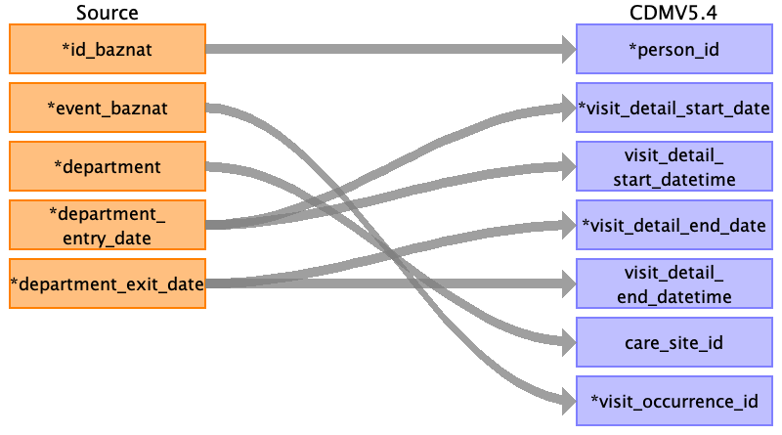

|  |  |  |  |
| --- | --- | --- | --- |
| Destination Field | Source Field | Logic | Comment |
| visit_detail_id |  |  | ID run |
| person_id | ﻿id_baznat |  |  |
| visit_detail_concept_id |  |  | InpatientVisit_concept_id 9201 |
| visit_detail_start_date | department_entry_date |  | Only date DD/MM/YYYY |
| visit_detail_start_datetime | department_entry_date |  | Date and time - DD/MM/YYYY HH:MM:SS |
| visit_detail_end_date | department_exit_date |  | Only date DD/MM/YYYY |
| visit_detail_end_datetime | department_exit_date |  | Date and time - DD/MM/YYYY HH:MM:SS |
| visit_detail_type_concept_id |  |  | EHR_concept_id 32817 |
| provider_id |  |  | Not know! |
| care_site_id | department |  | Based by the care_site table and event baznat. |
| visit_detail_source_value |  |  | Not use in this field. |
| visit_detail_source_concept_id |  |  | EHR_concept_id 32817 |
| admitted_from_concept_id |  |  | 0 |
| admitted_from_source_value |  |  | Not use in this field. |
| discharged_to_source_value |  |  | Not use in this field. |
| discharged_to_concept_id |  |  | Not use in this field. |
| preceding_visit_detail_id |  |  | Not use in this field. |
| parent_visit_detail_id |  |  | Not use in this field. |
| visit_occurrence_id | event_baznat |  |  |

Table name: condition_occurrence

Table name: drug_exposure

Table name: procedure_occurrence

Table name: device_exposure

Table name: measurement

Table name: observation

Table name: death

Table name: note

Table name: note_nlp

Table name: specimen

Table name: fact_relationship

Table name: location

Table name: care_site

Reading from 92.csv

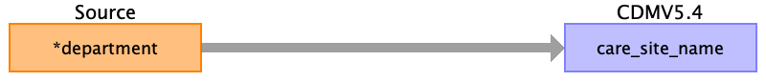

|  |  |  |  |
| --- | --- | --- | --- |
| Destination Field | Source Field | Logic | Comment |
| care_site_id |  |  | Id run |
| care_site_name | department |  |  |
| place_of_service_concept_id |  |  | concept id = 9201 |
| location_id |  |  |  |
| care_site_source_value |  |  |  |
| place_of_service_source_value |  |  |  |

Table name: provider

Table name: payer_plan_period

Table name: cost

Table name: drug_era

Table name: dose_era

Table name: condition_era

Table name: episode

Table name: episode_event

Table name: metadata

Table name: cdm_source

Table name: cohort

Table name: cohort_definition

Appendix: source tables

Table: 92.csv

|  |  |  |  |
| --- | --- | --- | --- |
| Field | Type | Most freq. value | Comment |
| ﻿id_baznat | INT | 6206416 |  |
| event_baznat | INT | 27524520 |  |
| sorter | INT | 1 |  |
| department | VARCHAR | Intermediate Maternity (DRG) |  |
| department_entry_date | VARCHAR | 04/06/2019 15:38 |  |
| department_exit_date | VARCHAR |  |  |

Table: book1.csv

|  |  |  |  |
| --- | --- | --- | --- |
| Field | Type | Most freq. value | Comment |
| ﻿id_baznat | INT |  |  |
| mother_id_baznat | INT |  |  |
| hosp_entry_date | INT |  |  |
| hosp_exit_date | INT |  |  |
| event_baznat | INT |  |  |
| emg_event_baznat | INT |  |  |
| cham_hosp_entry_date | INT |  |  |
| cham_hosp_exit_date | INT |  |  |
| age_category | INT |  |  |